Lecture 06B – Homework Using database db03

Use the database file db03

Name the file ‘06BHomework.txt’

These queries use both the airplane package system schema, and the meetings schema.

#1 This is a copy of the last classwork problem.

Compute how much money we owe and to whom, based on a subsidy of $15 per cell phone, and $1 for every seat available in a meeting room where we had a meeting.

For Name either print the employees name, or print the ‘<Building> <roomnumber>’ for the room;

Columns: **name, amount_due**

OrderBy: name

#2 Find the number of shippers in each status level. ( Platinum, Gold, etc) . Total shippers with no status as ‘NoStatus’ in the description field.

Columns: **description, number**

Order By : description

For those shippers who do not have a status level say ‘NoStatus’

#3 Select all packages that are Green and GT 25 lb or Red and GT 30 lb or Unknown and > 35 lb

For unknown colors print ‘Unknown’ as color name

Columns: **barcode color weight**

Order By: color, barcode

#4 Provide a count of every color package in the system. For unknown colors use ‘Unknown’ as the color name.

Columns: **color total_weight**

Order By: color

#5 Provide a list of location of all packages for every customer. Possible locations are:

‘At Terminal <ICAO>’

‘En Route to <ICAO>’

‘Picked up’

Columns **firstname, lastname, barcode, location**

Order By lastname, firstname, barcode;

#6 Compute profit for each shipper

Calculation is. $0.15 a lb , plus $1.00 per shipment.

Shippers with no shipments -$0.50

Show to two decimal places.

Columns: lastname, firstname, profit

Order By: lastname, firsname

#7 Find all airports with no custom rooms ( localID of ‘C’)

Columns **icao**

Order By: icao

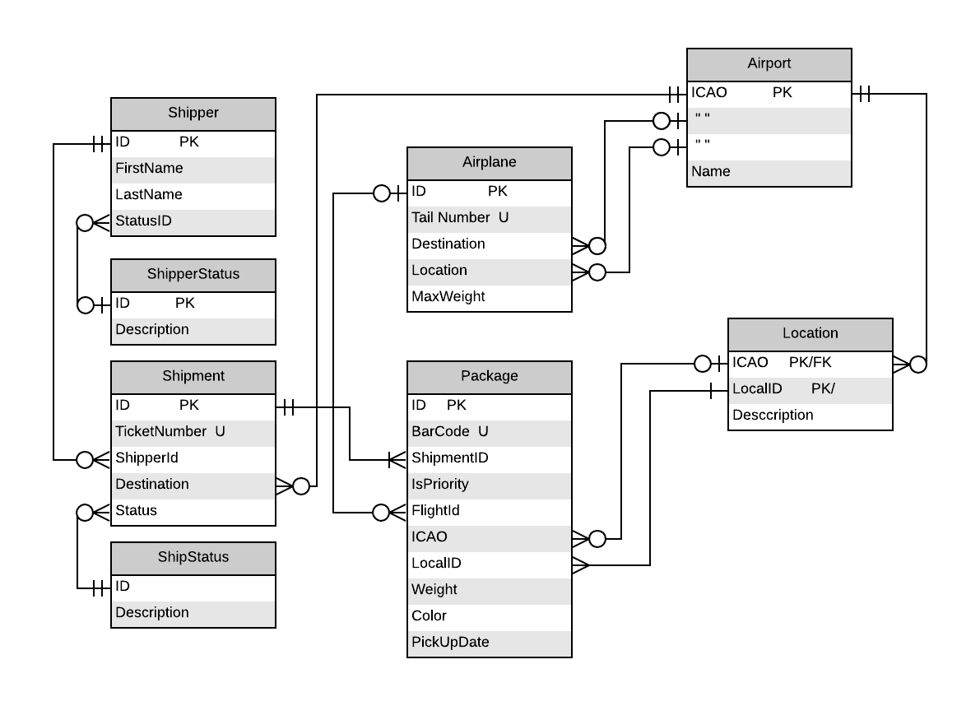

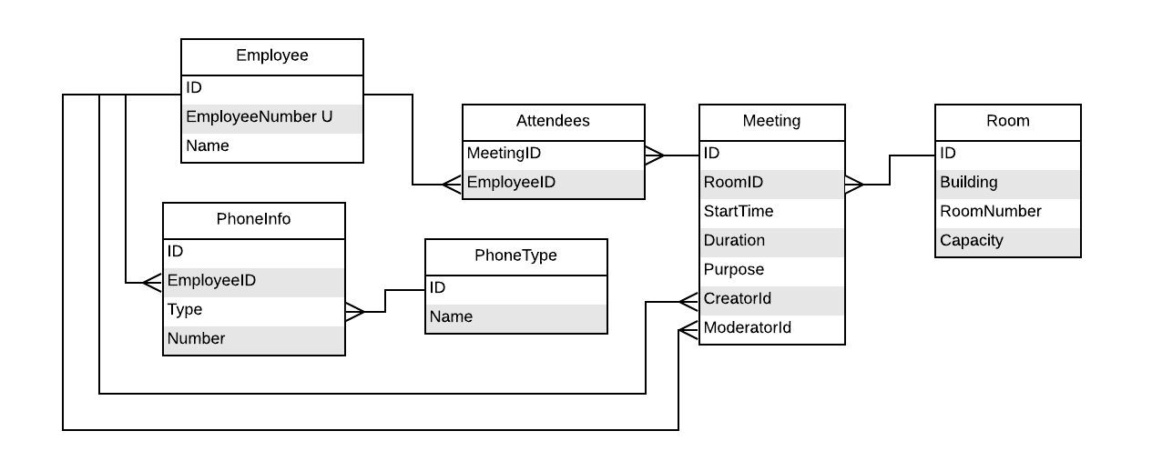

**Expected Output:**

Homework 06B

#1 ( This is the final problem in homework)

name | amount_due

--------+------------

A 101 | 40.00

A 102 | 30.00

A 103 | 40.00

A 104 | 20.00

Albert | 15.00

Alice | 15.00

Ariel | 15.00

B 101 | 80.00

B 201 | 40.00

B 202 | 30.00

Dan | 15.00

Dave | 15.00

Jack | 15.00

James | 15.00

John | 15.00

Martha | 15.00

Sarah | 15.00

(17 rows)

#2 Provide a count for number of shippers in each status. NoStatus for none.

description | number

-------------+--------

Bronze | 3

Gold | 3

NoStatus | 8

Platinum | 3

Silver | 2

(5 rows)

#3 Select all packages that are Green and GT 25 lb, Red and GT 30, or Unknown and > 35.

For unknown colors - print

barcode | color | weight

---------+---------+--------

100001 | Green | 145

100010 | Green | 112

100017 | Green | 128

100020 | Green | 120

100029 | Green | 36

100031 | Green | 31

100035 | Green | 29

100008 | Red | 130

100024 | Red | 119

100028 | Red | 139

100032 | Red | 136

100048 | Red | 38

100053 | Red | 150

100002 | Unknown | 180

100006 | Unknown | 123

100007 | Unknown | 119

100011 | Unknown | 119

100013 | Unknown | 131

100018 | Unknown | 111

100019 | Unknown | 128

100021 | Unknown | 117

100026 | Unknown | 140

100027 | Unknown | 140

100038 | Unknown | 114

100045 | Unknown | 36

100047 | Unknown | 138

100055 | Unknown | 128

(27 rows)

#4 Count the number of packages by color. For packages with no color use Unknown

color | total_weight

---------+--------------

Black | 588

Blue | 975

Green | 662

Red | 737

Unknown | 1897

(5 rows)

#5 For every package in the system find

Valid locations. At Terminal <ICAO>

In Route To <ICAL>

Picked UP

firstname | lastname | barcode | location

-----------+------------+---------+------------------

John | Bradshaw | 100016 | At Terminal KEUG

John | Bradshaw | 100017 | At Terminal KEUG

John | Bradshaw | 100018 | At Terminal KSEA

John | Bradshaw | 100019 | At Terminal KSEA

John | Bradshaw | 100020 | At Terminal KSEA

John | Bradshaw | 100021 | En Route to KSLE

John | Bradshaw | 100022 | At Terminal KSEA

John | Bradshaw | 100023 | At Terminal KSEA

John | Bradshaw | 100043 | At Terminal KSEA

Martha | Chenault | 100007 | At Terminal KPDX

Martha | Chenault | 100008 | En Route to KSLE

Stu | Cotts | 100009 | At Terminal KSEA

Stu | Cotts | 100010 | At Terminal KSEA

Stu | Cotts | 100011 | En Route to KSLE

Stu | Cotts | 100012 | En Route to KSLE

Stu | Cotts | 100052 | At Terminal KSEA

Fred | Flintstone | 100030 | En Route to KSEA

Fred | Flintstone | 100031 | Picked Up

Fred | Flintstone | 100032 | En Route to KSEA

Fred | Flintstone | 100050 | At Terminal KSEA

Fred | Flintstone | 100051 | At Terminal KSEA

Ben | Franklin | 100001 | En Route to KEUG

Ben | Franklin | 100002 | En Route to KEUG

Ben | Franklin | 100003 | En Route to KEUG

Thomas | Jefferson | 100028 | At Terminal KBLI

Thomas | Jefferson | 100029 | At Terminal KSEA

George | Martin | 100036 | At Terminal KSEA

George | Martin | 100037 | At Terminal KSEA

George | Martin | 100038 | At Terminal KSEA

Fred | Rogers | 100039 | At Terminal KSEA

Fred | Rogers | 100040 | At Terminal KSEA

Fred | Rogers | 100041 | At Terminal KSEA

Fred | Rogers | 100042 | At Terminal KSEA

Barney | Rubble | 100033 | At Terminal KSEA

Barney | Rubble | 100034 | At Terminal KSEA

Barney | Rubble | 100035 | At Terminal KBLI

Barney | Rubble | 100047 | At Terminal KSEA

Barney | Rubble | 100048 | At Terminal KSEA

Martha | Washington | 100004 | Picked Up

Martha | Washington | 100005 | Picked Up

Martha | Washington | 100024 | En Route to KEUG

Martha | Washington | 100025 | En Route to KEUG

Martha | Washington | 100026 | En Route to KEUG

Martha | Washington | 100027 | En Route to KEUG

Fred | Zurgulost | 100044 | At Terminal KSEA

Fred | Zurgulost | 100045 | At Terminal KSEA

Fred | Zurgulost | 100046 | At Terminal KSEA

Fred | Zurgulost | 100049 | At Terminal KSEA

Fred | Zurgulost | 100053 | At Terminal KSEA

Fred | Zurgulost | 100054 | At Terminal KSEA

Fred | Zurgulost | 100055 | At Terminal KSEA

(51 rows)

#6 compute profit per shipper. $0.15 per lp + $1.00 shipment. Loss of $0.5 for shippers with no shipments

lastname | firstname | profit

------------+-----------+--------

Adams | Mary | -0.50

Adans | John | -0.50

Bradshaw | John | 153.75

Chenault | Martha | 38.35

Cotts | Stu | 59.60

Disney | Walt | -0.50

Flintstone | Fred | 36.05

Franklin | Ben | 70.45

Jefferson | Thomas | 27.25

Martin | George | 88.55

Martin | Wilma | -0.50

Rabbit | Roger | -0.50

Rogers | Fred | 13.45

Rubble | Barney | 39.05

Smith | John | -0.50

Smith | John | -0.50

Spade | Sam | -0.50

Washington | Martha | 141.50

Zurgulost | Fred | 80.85

(19 rows)

#7 Find any airports with no Customs room.

icao

------

KBLI

KEUG

KGEG

KLAX

KMED

KPDX

KSLE

(7 rows)